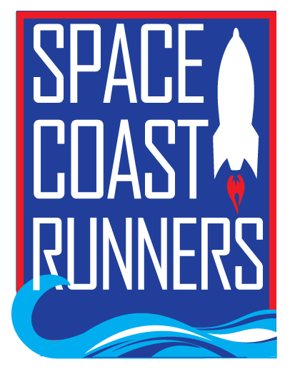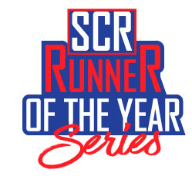 | SPACE COAST RUNNERS  AMBASSADOR APPLICATION  2022-2023

SCR Ambassador Application (application submission deadline is 5/27/22)
Name: |  |  |  |  |  | DOB:
Address:
 | City |  |  |  | State |  |  | ZIP Code
Phone: |  |  | Email:

Current SCR Member? Yes ____ No ____ Occupation: ___________________________________________

Current Age: _____________________ Favorite Race: ___________________________________________

Facebook Handle: __________________________________________________________________________

Singlet Sizing: ____ Men ____ Women | Sizes: XS ____ S ____ M ____ L ____ XL ____ 2XL ____

Jacket Sizes (unisex): | XS ____ S ____ M ____ L ____ XL ____ 2XL ____

APPLICATION INFORMATION
An application committee will be formed to select team members based on the following criteria:

- Commitment to SCR
- Application responses
- Assessment of SCR ambassador and club representation

I have read and understand the selection criteria: ____ Yes ____ No

AMBASSADOR REQUIREMENTS
- Have a current membership with Space Coast Runners
- Be at least 18 years of age
- Represent SCR as a club ambassador throughout Brevard County
- Run/walk or volunteer at one SCR or non-SCR event per month
- Write a blog post for the SCR newsletter – share your testimonial, tell us about your favorite SCR race, review running shoes, provide encouraging advice to new runners/walkers, the list goes on! You choose!
- Share all Space Coast Runners social media posts on personal social media accounts
- Consent to use of image for marketing purposes.
- Sign a Code of Conduct agreement
Note: Ambassadors who do not satisfy requirements may be removed from the program

I have read, understand and agree to meet or exceed all program expectations: ____ Yes ____ No

QUESTIONS Attach answers to application.
- Why do you want to participate in the SCR Ambassador Program?
- Describe how you will contribute to SCR and the SCR Ambassador Program.
- Describe your running/walking and volunteer goals for the 2022-2023 race season.
- Describe a running/walking related accomplishment, memory or interesting story. (If selected for the ambassador program, this will be used for introductions in SCR promotions, social media, etc.)
- Do you have any questions or concerns about the SCR Ambassador Program?

PLEASE SIGN By signing below, I certify all information is true and correct.

Signature of Applicant: _______________________________________________ Date Signed: ________
SUBMIT APPLICATION TO: RACINGTEAM@SPACECOASTRUNNERS.ORG

